

*“The purpose of computing is insight, not numbers”*

***Richard W. Hamming - The art of doing science & engineering -* 1986**

**Introduction**

Theatre is about to begin. Two actors will perform on stage: the electric and magnetic fields, we will explore their interactions under different conditions. Electrostatics and magnetostatic phenomena are notorious for being among the most difficult to deal with in the laboratory. In the following pages, we will show how we have addressed these challenges both experimentally and computationally.

As *John P. A. loanidis* showed in *(2005) "Why most published research findings are false"*, we live in an era where most published scientific studies are difficult or even impossible to reproduce. Since reproducibility of experimental results is an essential part of the scientific method, the inability to replicate the studies of others has serious consequences for many fields of knowledge, not to mention how it slows down technological development in industry and technological adoption in society. Although this ongoing crisis primarily affects the fields of medicine, we want to contribute to a healthier research environment.

All data, methodologies, codes & results are public and free to be examined at the following [link](https://github.com/Fylls/electromagnetism-experiment).

**Table of contents**

**Experimen 1**  3

Theore tical backgound 3

Experimental apparatus 4

Procedure 5

Models 6

Results 8

Statistical analysis 10

**Experiment 2**

Theore tical backgound 13

Experimental apparatus 13

Procedure 14

Results 15

Statistical analysis 18

**Acknowledgements**  22

**Experiment 1**

assumptions and models for the correct calculation of the capacitance of a flat parallel plate capacitor

**Abstract**

In the experiment, we have two circular flat plates of radius R at a fixed initial distance of 1mm charged with a voltage generator. The capacitor is of variable capacitance since one of the plates is fixed, while the other is free to slide along a rail fitted with a metric scale. The aim is to measure the capacitance $C$ and the potential difference $∆V$ under different assumptions and models.

**Theoretical Background**

**Capacitance**

If a potential difference is applied to the plates of a capacitor, the charges separate and an electric field is generated within the *dielectric* (in this case air). The armature connected to the highest potential is positively charged, while the other is negatively charged. The positive and negative charges on the two plates are equal in absolute value. The ratio between the charge and the applied potential is called capacitance C and it is measured in *farad* (F).

$$globally: Q = ε_{0} \oint{ε_{r} E∙dA} ∆V= \int_{-}^{+}{E∙dS} C= \frac{Q}{∆V}=\frac{ε_{0} \oint{ε_{r} E∙dA}}{\int_{-}^{+}{E∙dS}}$$

**Hypothesis 1: Capacitor operates in vacuum**

The dielectric characteristics of air for electric fields well below $3,94 ∙{10}^{4} V/m$ are very similar to those of vacuum. Having calculated the maximum electric field reached inside our capacitor, we find that $2 ∙{10}^{3} V/m$ amply verifies this assumption. For subsequent calculations, we will neglect the relative dielectric constant.

$$ε_{r}=1$$

**Hypothesis 2: Capacitor is flat**

The capacitance of a capacitor with flat, parallel plates depends entirely on its geometric parameters. The local geometry of a flat capacitor allows important simplifications to be made for all points away from the edge. It is consequently assumed that E is constant throughout the volume between the plates.

The following formulas would apply globally if we were studying an infinite parallel plate capacitor.

$$locally: Q = ε_{0} E A ∆V= E d C= \frac{Q}{∆V}=\frac{ε_{0} A}{d}$$

**Experimental Apparatus**

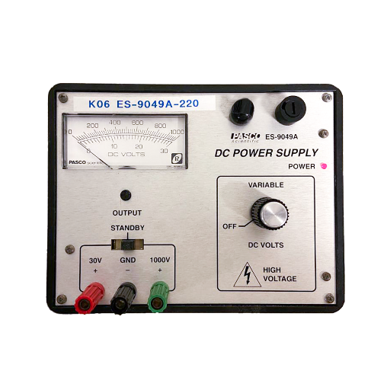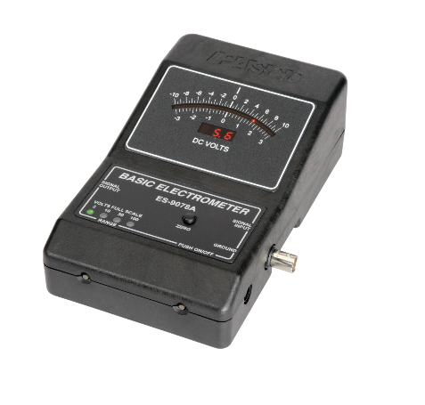

**Capacitor**: formed by two armatures (disks) of radius 10cm. One of the two disks is free to free to slide along a rail fitted with a metric scale with 1mm sensitivity.

**DC Power Supply:** utilizzato per caricare le armature tramite un cavo con morsetto. Tensione regolabile.

**Voltmeter:** utilizzato per misurare la differenza di potenziale fra le armature. Impostabile su tre diversi fondi scala per effettuare misurazioni su diversi voltaggi. Dispositivo Analogico.

**Anti Static Wrist Strap Band:** important for security reasons

Below, we report how the equipment is connected

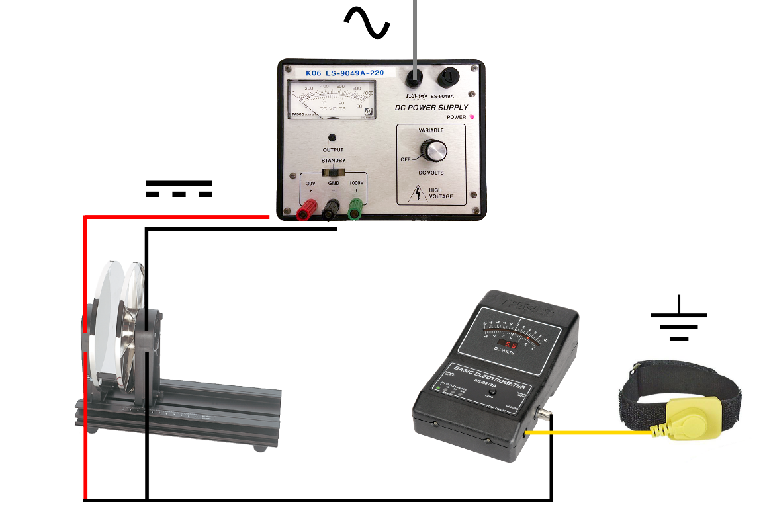

**Procedure**

To begin, we have removed all objects that could interfere with our experiment so as not to disperse the charge deposited on the plates of the capacitor.

Turned on the voltmeter, we connected it via terminals at the ends of the two plates. Subsequently, we set the voltage generator to 10 V (direct current) connecting it in a similar way. While the connections between voltmeter and capacitor remained unchanged throughout the experiment, the same cannot be said of the connection between generator and moving plate. In fact, the plate and cable made contact only to deposit the charge necessary to report the desired value (10, 15, 20 V) on the voltmeter. During the measurement phase the generator is disconnected in order to avoid the continuous deposit of new charge to keep the voltage constant. This ensures that it is not the voltage, but the charge deposited on the two armatures that remains unchanged during the experiment.

Thanks to the voltmeter (suitably zeroed through the function of the instrument) the potential differences at the various distances to which the two plates are brought through the slide. We bring the plates from the distance of 1mm (initial condition in which all previous operations are carried out) up to 40mm, taking care to perform all measurements in the shortest time possible. In this way we avoid that the charge deposited in the plates is dispersed by contact with the air. Unfortunately, the day in which we conducted the experiment was particularly humid due to bad weather conditions, a fact that favors the loss of charge because humid air is a worse insulator than dry air. We repeated the process of detection at the voltages set at the generator of 15V and 20V.

From the photo you can see how a cell phone placed parallel to the plane was used to magnify the millimeter scale and avoid parallax errors.

**Physical Models**

**Model 1: Infinite plate capacitor**

The infinite geometry of the capacitor allows the validity of hypothesis two to be extended globally. We assume that the plates of this capacitor are so large and close to each other that the edge effect of the electric field at the ends can be neglected.

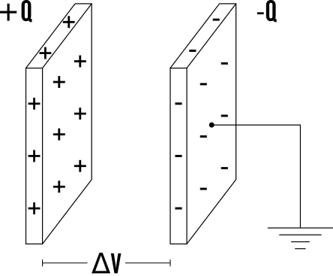

$$E_{∞}= \frac{Q}{ε_{0} A} ∀ punti P interni$$

$$V_{∞} = E_{∞} d= \frac{Q}{ε_{0} A} d_{min}$$

$$C_{∞} = \frac{Q}{V_{∞} }= \frac{ε_{0} A}{d_{min} }$$

**Model 2: Finite round plate capacitor**

In this model, we consider the finite geometry of our capacitor and proceed to calculate the electric potential along the axis of a uniformly charged disk.

The electric field generated by charge dQ at point P is given by:

$$dE= \frac{dQ}{4πε_{0}d^{2}}=\frac{σ dr dl}{4πε_{0}d^{2}}$$

It is observed that each infinitesimal stretch of circular corona generates an electric field identical in modulus to that generated by the diametrically opposite stretch. Given the geometry, the two vertical components cancel each other while the two horizontal components are summed for each pair of opposite points. Therefore we study only the horizontal component:

$${dE}_{x}=\frac{σ dr dl}{4πε_{0}d^{2}} cos⁡(θ)$$

We find the electric field generated along the axis by integrating for a distribution of concentric rings.

$${dE}_{r}=\int_{L}{{dE}_{x}= }\frac{σ dr \cos\left(θ\right) }{4πε_{0}d^{2}}\int_{L}{dl}=\frac{σ dr \cos\left(θ\right) }{4πε_{0}d^{2}} 2πr=\frac{σ r dr }{2ε_{0}d^{2}}\cos\left(θ\right)$$

From the definition of cosine it follows that:

$$\cos\left(θ\right)=\frac{x}{d}= \frac{x}{\sqrt{x^{2}+ r^{2}}} poichè d= \sqrt{x^{2}+ r^{2}}$$

Now it is possible to write the formula of the electric field generated by the corona in P in the following way:

$${dE}_{r}=\frac{σ r dr }{2ε_{0}d^{2}}\frac{x}{d}=\frac{σ r dr }{2ε_{0}}\frac{x}{{{(x}^{2}+ r^{2})}^{3/2}}$$

Integrating from 0 to R we get the electric field generated along the axis of a disk, since there are two disks in a capacitor, we multiply by two:

$$E_{disk}=2\int_{0}^{R}{{dE}_{r}= }\frac{|σ| }{ε_{0}} \left( 1-\frac{x}{\sqrt{x^{2}+ R^{2}}} \right) (x>0)$$

By integrating again, it is possible to find the potential difference straddling the two armatures:

$$V_{disk}=-\int_{0}^{d_{min}}{ E_{disk} dx= }\frac{Q}{ε_{0}A} \left( d_{min}+R- \sqrt{{d_{min}}^{2}+ R^{2}} \right)$$

From there, the theoretical capacity of the disk is derived:

$$C_{disk}=\frac{Q}{V_{disk} }=\frac{ε_{0}A}{\left(d_{min}+R - \sqrt{{d_{min}}^{2}+ R^{2}}\right)}$$

**Note:**

with $d$ we mean the generic distance between two points on different plates, with $d_{min}$ we mean the minimum distance, that is the perpendicular that joins the plates

**Modello 3: Parasitic capacity**

Dai dati si nota che il voltaggio del disco non ricalca perfettamente ciò che si è ottenuto dai dati sperimentali. Per migliorare ulteriormente il modello ora si tiene anche conto della capacità parassita del voltmetro.

$$C_{disk}+ C_{parasitic}= C_{total}{ where C}_{total}=\frac{Q}{V_{experimental} }$$

Si procede quindi al calcolo della capacità parassita che permette di rendere il nostro *modello compatibile* con i dati sperimentali. Le capacità si sommano poiché in *parallelo*.

$$C_{parasitic}= C_{total}- C_{disk}=Q ∙ \left(\frac{1}{V_{experimental} }- \frac{1}{V_{disk} }\right)$$

**Results**

Interactive data and graphs are available by clicking on the following links above:

[10 volt](https://www.desmos.com/calculator/oiitwmcjik) [15 volt](https://www.desmos.com/calculator/kzzdbjxhi7) [20 volt](https://www.desmos.com/calculator/agbq9bk9nm)

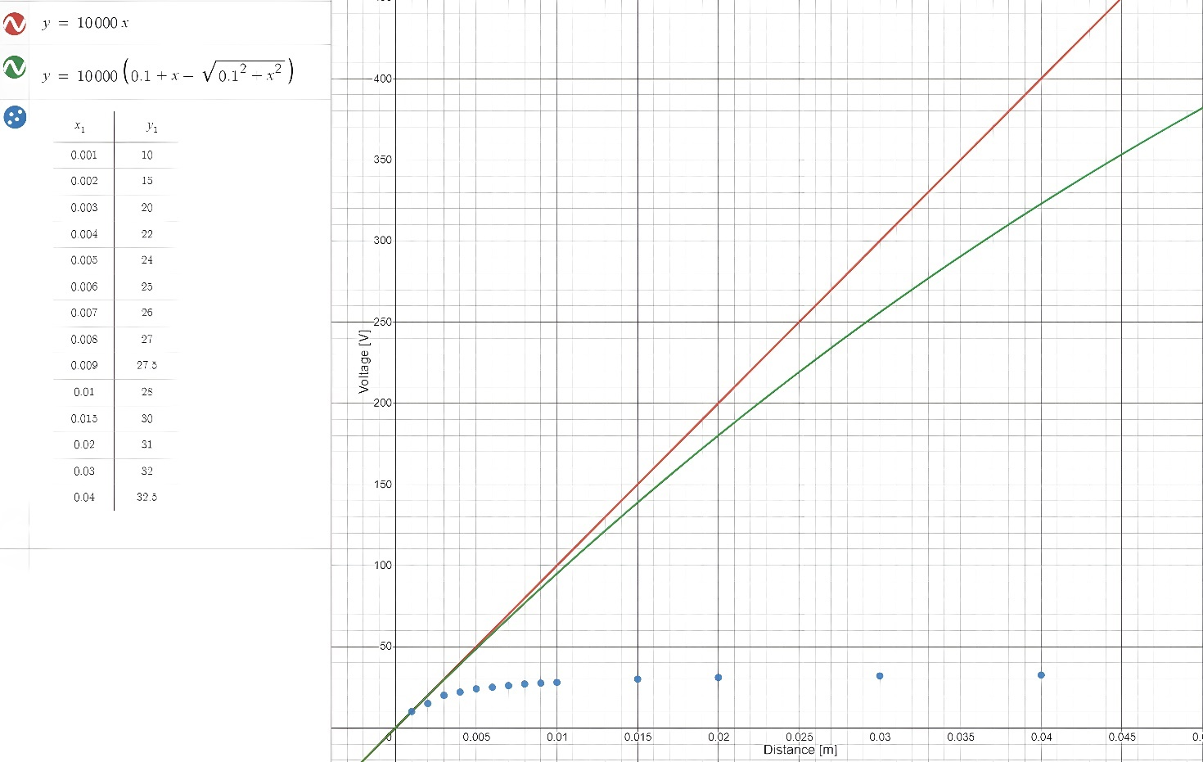

Only the graph related to the measurements with initial $∆V$ equal to 10V is shown because all three graphs are similar. As we can see the first two models are unsatisfactory for distances greater than 5mm, towards 10mm it is noted in fact that the electric potential tends to saturate (reach a constant value).

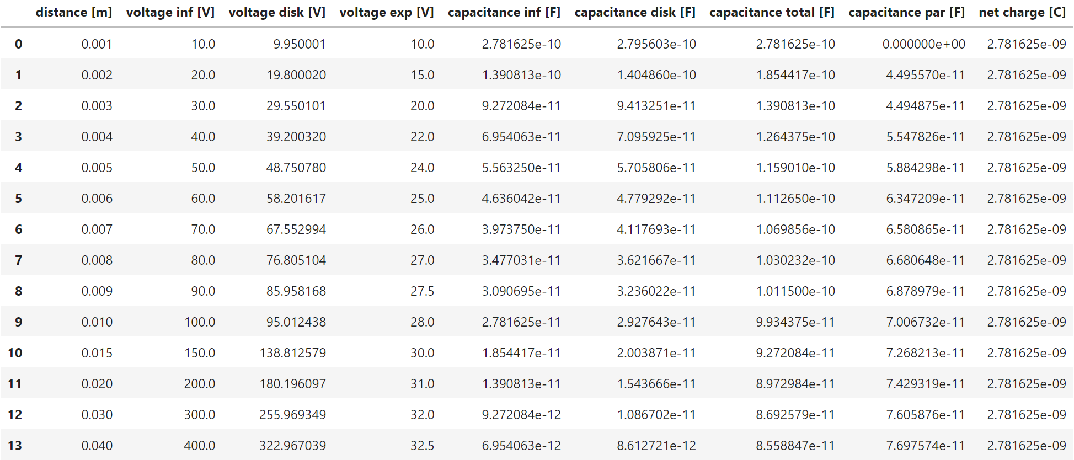

We believe that every researcher should be transparent on how he analyzes his data; therefore, we report the following code in Python with which the value of the parameters of interest was calculated as a function of distance.

As we were advised by the professors, if in the calculations a negative parasitic capacitance was encountered (in our case at 1mm) it is considered null. A negative capacitance has no physical meaning.

By averaging the measurements of the parasisitc capacitance we conclude that it has a mean value of:

$$C_{parasitic}= 5.994141716657975 ∙{10}^{-11} F$$

$$σ \left(C_{parasitic}\right)= 1.9376964418567223∙{10}^{-11}$$

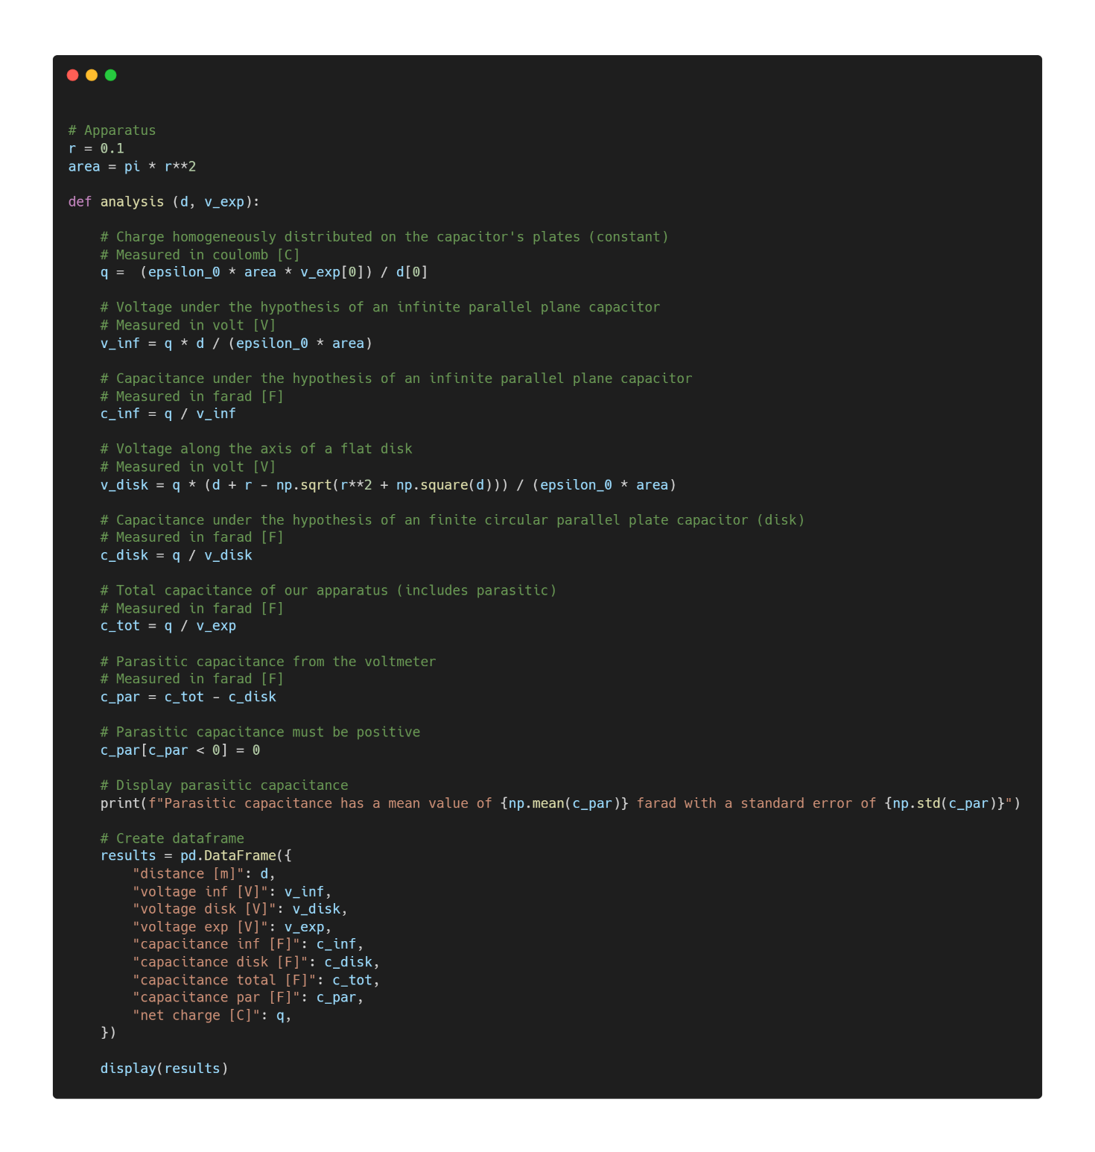

More information about how the code was written is available by clicking [here](https://github.com/Fylls/electromagnetism-experiment/blob/main/analysis/analysis1.ipynb).

**Statisical Analysis**

**Linear Regression**

Only the case for measurements with initial $∆V$ equal to 10 V is reported since all three cases are similar. Analyses of the other cases can be found at the following [link](https://github.com/Fylls/electromagnetism-experiment/tree/main/statistics).

The theoretical models initially proposed should approximate the experimental voltage by excess. We study the linear relationship that most closely approximates these models while attempting to optimize the significance of the predictors.

Linear regression using all data first. Refined model later using only the first eight.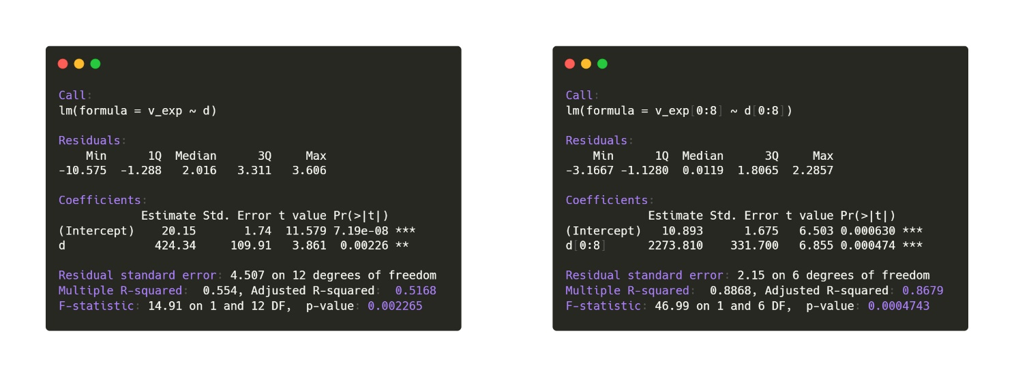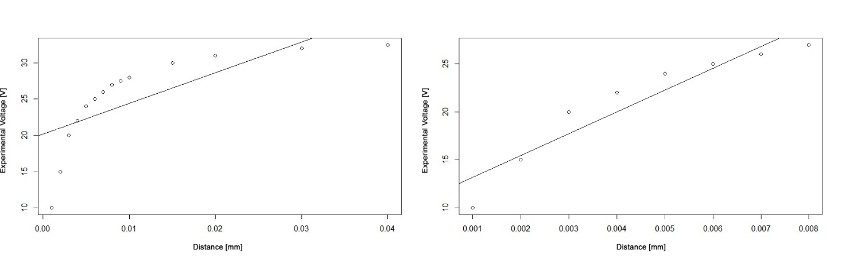

*Density and QQplot for the residuals. p-value of the SW test: 0.5627 - gaussianity not rejected. From the third plot we note that the residuals are homoskedastic and have bias.*

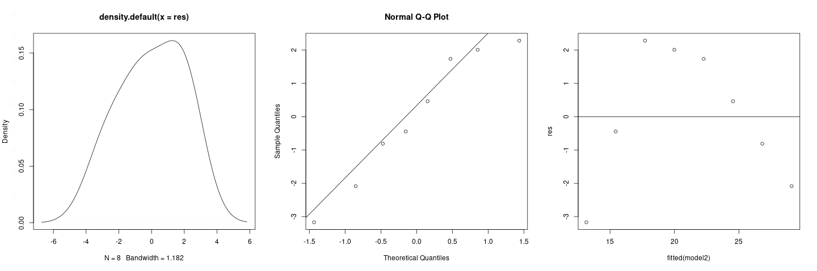

**Normality**

Studying the QQ-plots we notice that the measurements obtained follow a normal trend; a following Shapiro-Wilk test with a p-value of 0.159 leads to accept the Gaussianity of the samples. It is important to remember that the Shapiro-Wilk test places the Gaussianity in the null hypothesis H0; this means that it is not possible to strongly assert the Gaussianity of the samples. However, we also do not have strong evidence to reject this hypothesis. Thus, one has a conclusion that statisticians call "weak". There are no tests that strongly conclude the Gaussianity of a random sample.

*Density and QQplot of all experimental data*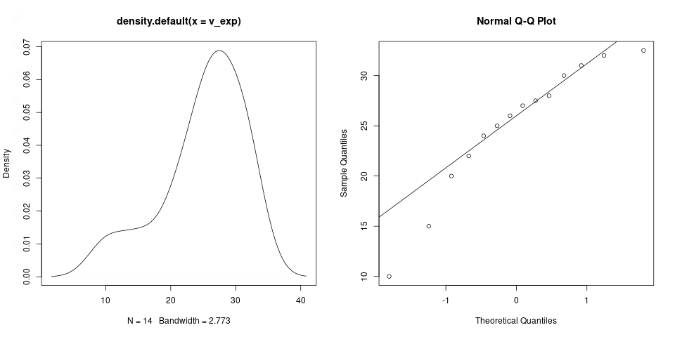

*Density and QQplot for the first eight experimental data (used in the regression) SW test p-value: 0.2287 - gaussianity not rejected*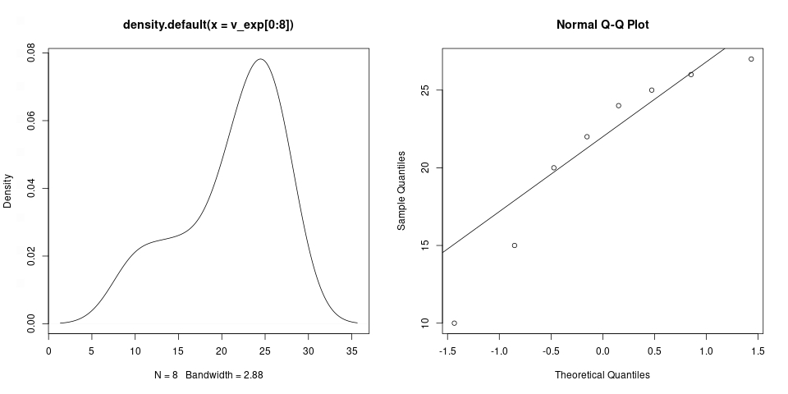

Again, we feel it necessary to leave the R [code](https://github.com/Fylls/electromagnetism-experiment/tree/main/statistics) used for our analysis.

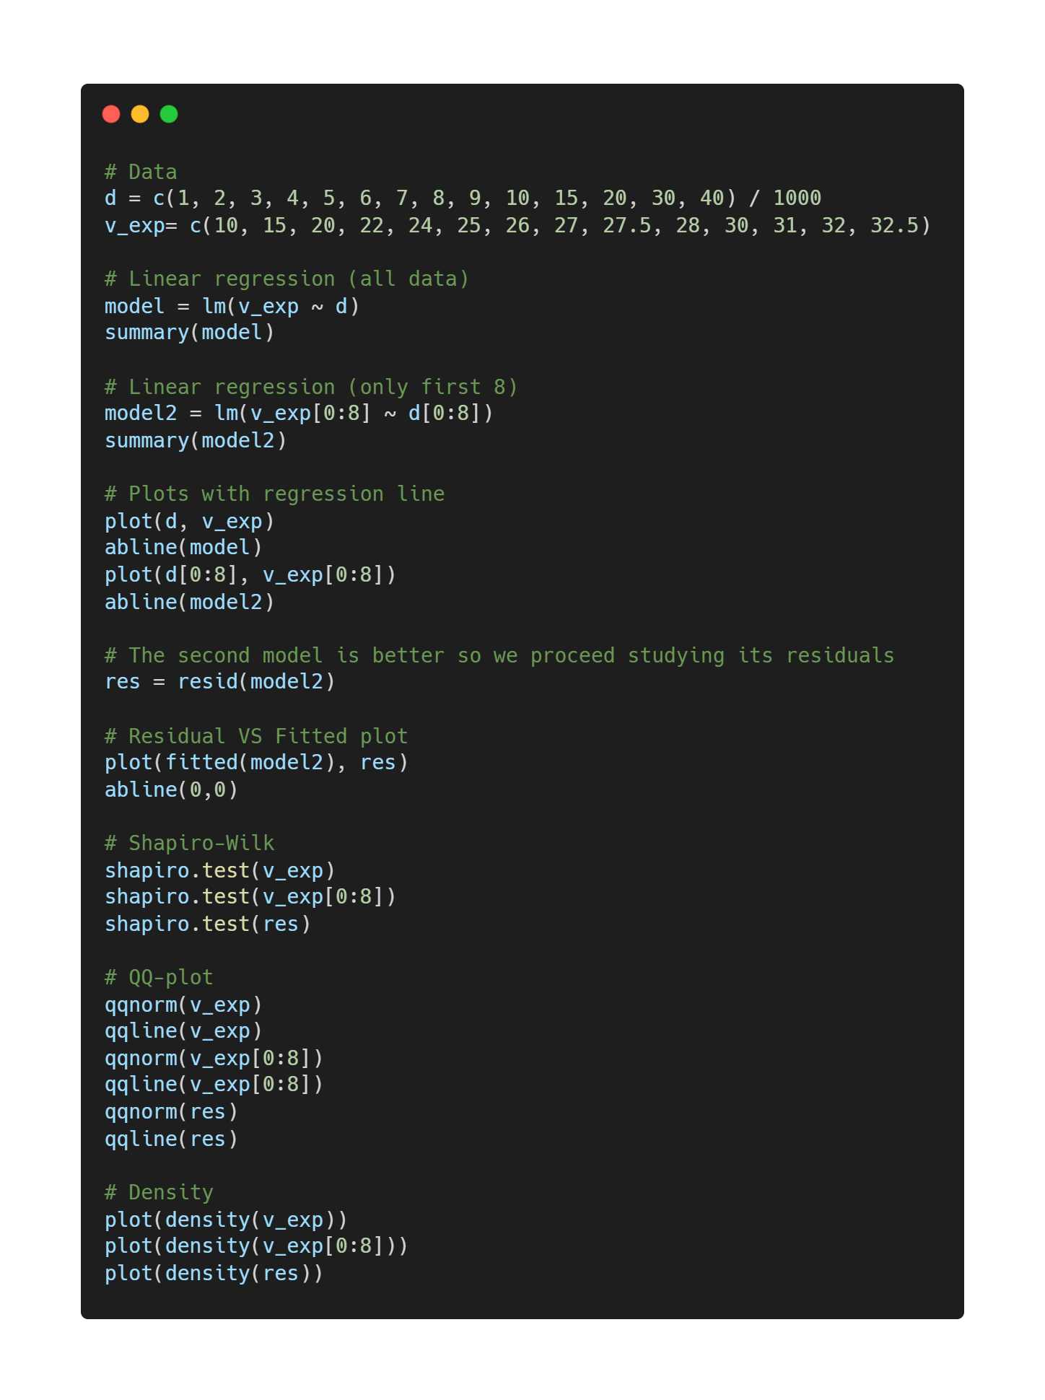

**Experiment 2**

Verifica sperimentale della legge di Laplace

**Abstract**

L’obbiettivo di questi esperimenti è verificare la legge di Laplace studiando la vicendevole dipendenza tra le variabili in gioco (corrente, lunghezza del circuito e angolo tra densità di corrente e campo magnetico). I modelli teorici risultano compatibili ai dati sperimentali, ciò ci permette di studiare l’intensità del campo generato dei magneti in margine con un errore pressoché minimo.

**Theoretical Background**

**Legge di lorentz**

**Come ricavo laplace**

**Legge di Laplace:**

Un filo rettilineo percorso da una corrente I ed immerso in un campo magnetico B è soggetto alla forza F. Verso e direzione della forza seguono direttamente dal fatto che vettore forza, campo magnetico e densità di corrente formano una *terna destrorsa* (si può applicare la *regola della mano destra*).

$$\vec{F} = I \vec{L} ×\vec{B} \left|F\right|= I L B sin\left(ϑ\right)$$

Immsgine spira e aggiungo forze con photoshop e spiego la cosa delle bilance

**Experimental Apparatus**

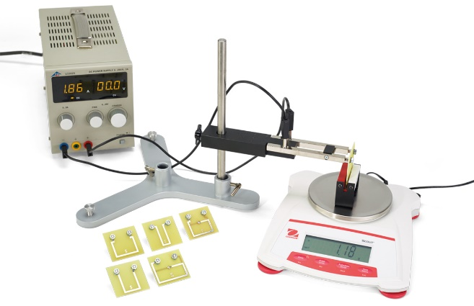

**Set di circuiti:** importante per la seconda parte dell’esperimento. Il set comprende circuiti di lunghezza variabile da 10 a 80 mm. Tutti i circuiti sono compatibili con il *supporto conduttore*.

**Magnete a ferro di cavallo:** comodo poiché genera un campo magnetico *uniforme* all’interno della sua cavità.

**Bilancia di precisione:** strumento digitale. Sensibilità in 10-5 Kg (*centigrammo*). Funzionalità di tara inclusa.

**Generatore di Corrente:** utilizzato per far passare *corrente continua* all’interno del circuito. Regolabile.

**Bobina rettangolare**: montata su un supporto che permette una rotazione fino a 180°. Dieci avvolgimenti.

**Procedure**

**1) Variable current:**

At this stage of the experiment the length of the circuit is fixed at 4 cm while the current intensity is variable from 1 to 4 amperes (A).

The circuit is placed inside the magnet cavity perpendicular to the work surface by the conductive support. It is important to keep the circuit parallel to the magnet walls to prevent the angle from affecting the measurements. The field is considered uniform inside the cavity, so it is not necessary to place the circuit perfectly in the center, but in any case preferable.

The magnet is located on the because it is possible to indirectly measure the vertical force to which the magnet the magnet is subjected (as a consequence of the principle of action and reaction) in correspondence of the different values of current set to the generator.

Magnet and current are oriented in such a way as to produce a downward force, as the balance is more accurate for positive changes in mass and not vice versa.

The total force acting along the vertical sum is the vector sum of the weight force and the Laplace force the reaction; fortunately the balance is able to measure relative variations with respect to an indicated mass, this allows to know with simplicity the variation of apparent mass due to the action of the force.

The Laplace force is obtained by multiplying the variation of mass in kilograms by the acceleration of gravity.

$$F_{Laplace}= ∆m∙g=I L B$$

$$si assuma sin\left(ϑ\right)=1 → ϑ= π/2$$

**2) Variable Length:**

This phase of this experiment is similar to the previous one. Unlike the first phase the current set to the generator is fixed at 3 A, while the length of the circuit inserted on the conductor support varies.

This condition is obtained by connecting to the conductor support circuits of different lengths, part of the experimental set previously described. The lengths vary from 10 to 80 mm.

It is essential to remember that before changing the circuits it is necessary to turn off the current generator to avoid accidents. In any case the current of 3 A is high enough to have visible results but not enough to create dangerous situations.

$$F_{Laplace}= ∆m∙g=I L B (ϑ= π/2)$$

**3) Variable Angle:**

The latter is characterized by the use of a special tool that allows us to vary the angle between current density and magnetic field precisely without changing the structure of the system, which is similar to previous cases. The length of the circuit and the current intensity are constant and are worth respectively 1cm and 3 A. The loop has 11 windings.

$$F_{Laplace}= ∆m∙g=N I L B sin\left(ϑ\right)$$

**Risultati Sperimentali**

Dati e Grafici Interattivi possono essere trovati cliccando sopra i seguenti link:

[prova1](https://www.desmos.com/calculator/h4bduk6eou) [prova2](https://www.desmos.com/calculator/zjzzpchrwf) [prova3](https://www.desmos.com/calculator/kxejprp3qt)

**1) Variable current:**

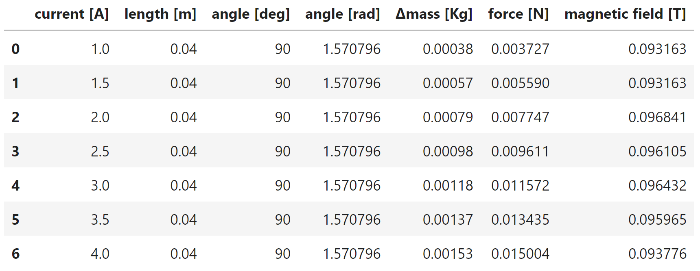

$$B_{1}= 0.09506363038690477 T$$

$$σ \left(B_{1}\right)= 0.0015028110582847372$$

**2) Variable Length:**

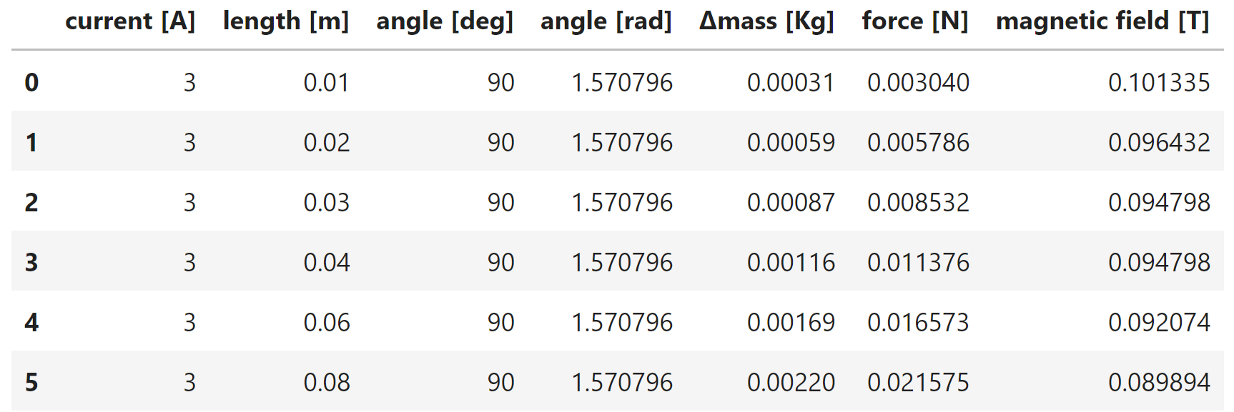

$$B_{1}= 0.09488841898148148 T$$

$$σ \left(B_{1}\right)= 0.0035783486084375207$$

**3) Variable Angle:**

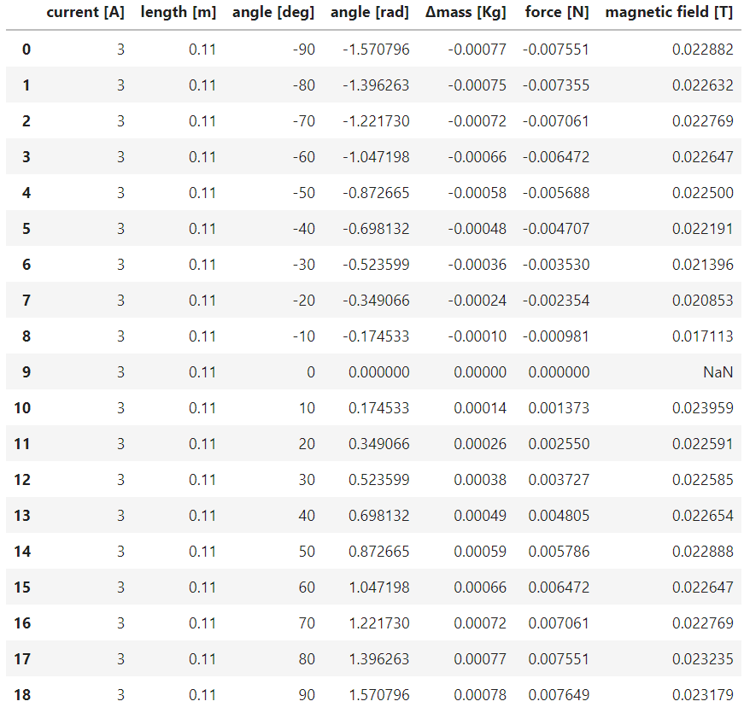

$$B_{2}= 0.02230510145458343 T$$

$$σ \left(B_{2}\right)= 0.0014147961692990447$$

The magnet used in the first two experiments is different from the one used in the third, so we define B1 and B2. Considered with their errors, the two values of B1 are compatible and converge on a value of about 0.095T.

The magnetic field in the third table in line 9 is undefined (NaN) because since the angle is zero, its sine is also zero. Since it is not possible to divide by zero we obtain undefined.

For the correct calculation of the magnetic field it is necessary to convert the angles in radians.

The average magnetic field data can also be found as the first order coefficients in linear regressions that we will discuss later. The intercept has very high p-value, so we can exclude it from the model.

As in the previous cases we leave the code used for data analysis. More information [here](https://github.com/Fylls/electromagnetism-experiment/blob/main/analysis/analysis2.ipynb).

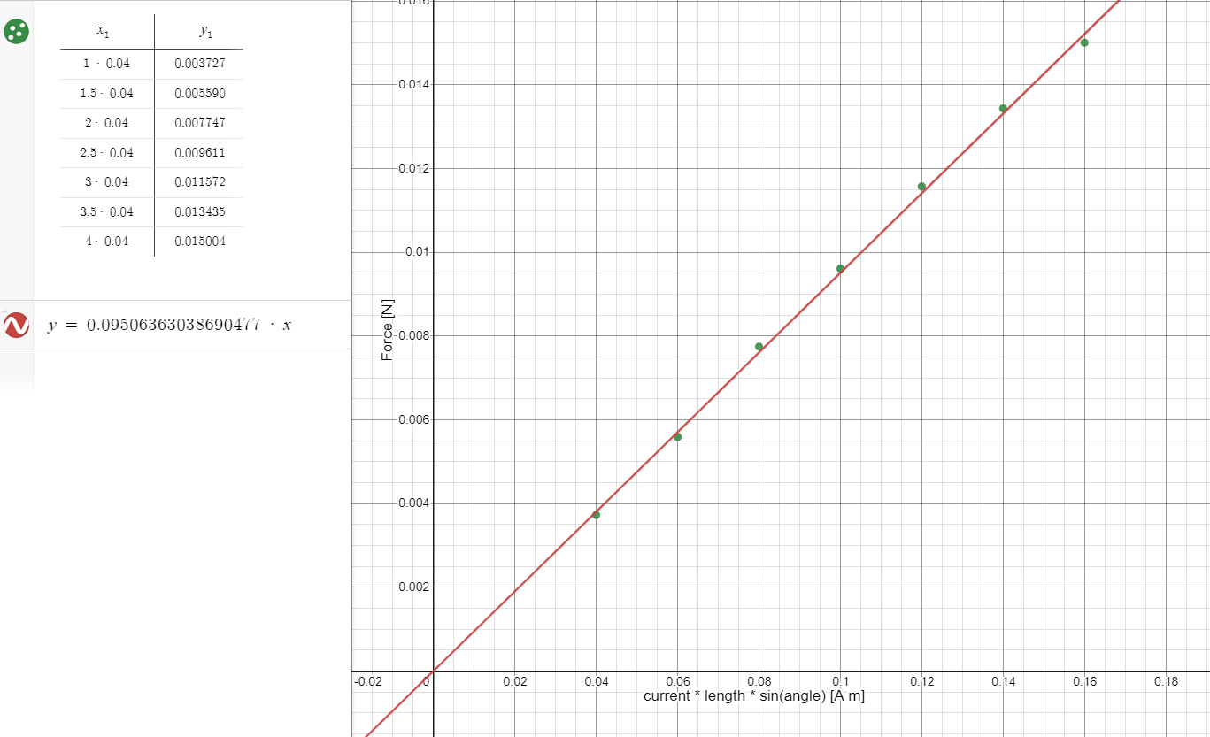

**Statistica Analysis**

**1) Variable Current:**

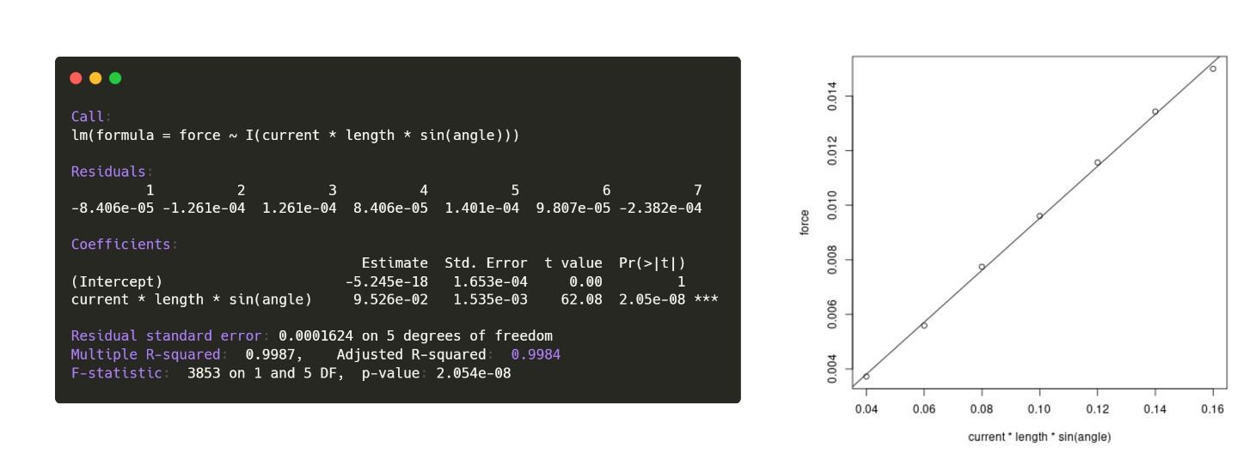

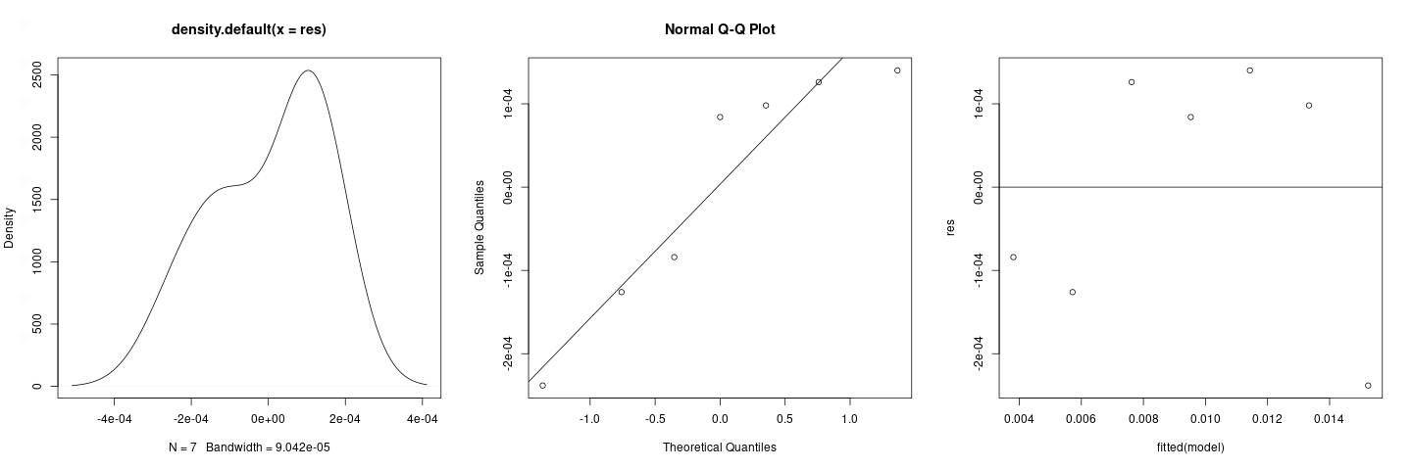

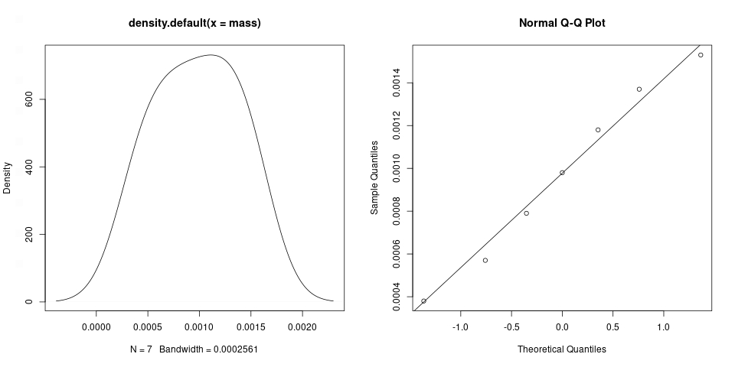

Gaussianity is not refutable for both samples and residuals; further confirmation of this comes from the Shapiro-Wilk test: 0.9099 >> 0.05 for mass, 0.1685 > 0.05 for residuals. From the third plot on the residuals (res vs fitted) we note homoschedasticity: the residuals have finite variance and a cloud-like arrangement. Overall significant regression (low p-value of F-test). Since the p-value of the intercept is maximum (1) this allows not to consider it in the model. R2 e R2adj are satisfactory.

**2) Variable Length:**

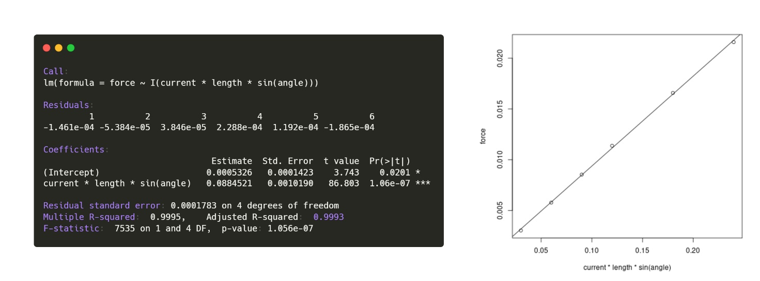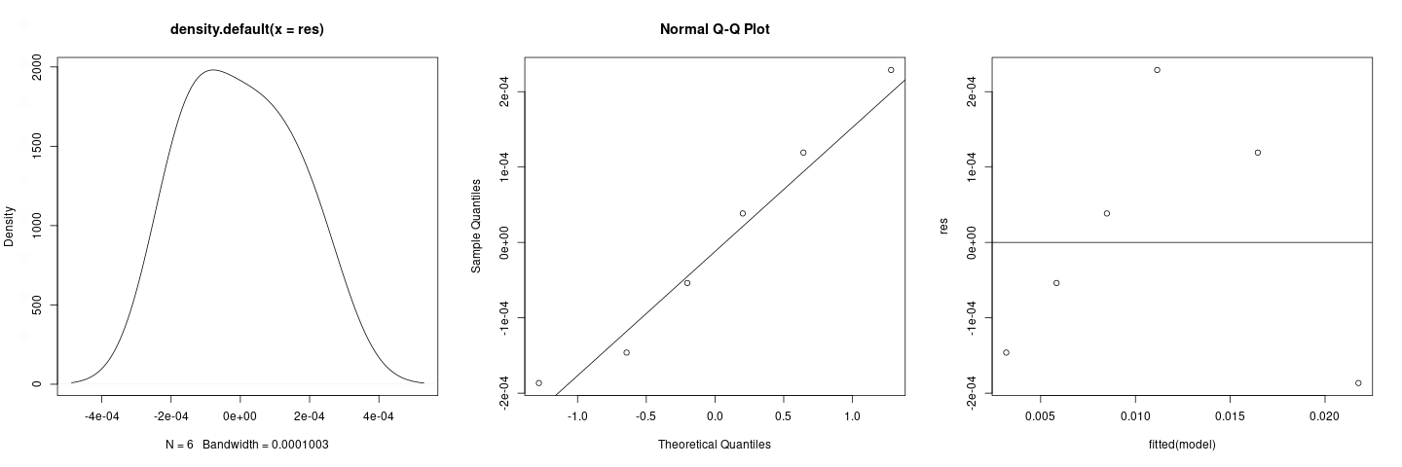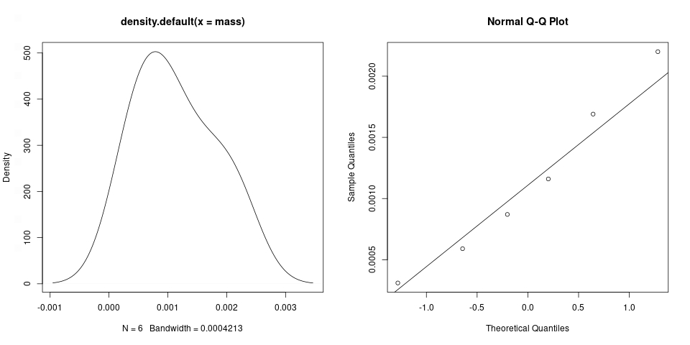

Gaussianity not refutable for both samples and residuals; further confirmation of this comes from the Shapiro-Wilk test: 0.8505 >> 0.05 for mass, 0.8359 >> 0.05 for residuals. From the third plot on the residuals (res vs fitted) there is a certain homoschedasticity with non-linear bias (maybe parabolic). In any case the residuals are perfectly kept within the ±2 margins of the normalized plot but it is not possible to conclude more for the lack of further data. Regression globally significant (low p-value of F-test). Intercept less significant than the other predictor (0.0201 >> 10-7) this allows not to consider it in the model. R2 e R2adj are satisfactory.

**3) Variable Angle:**

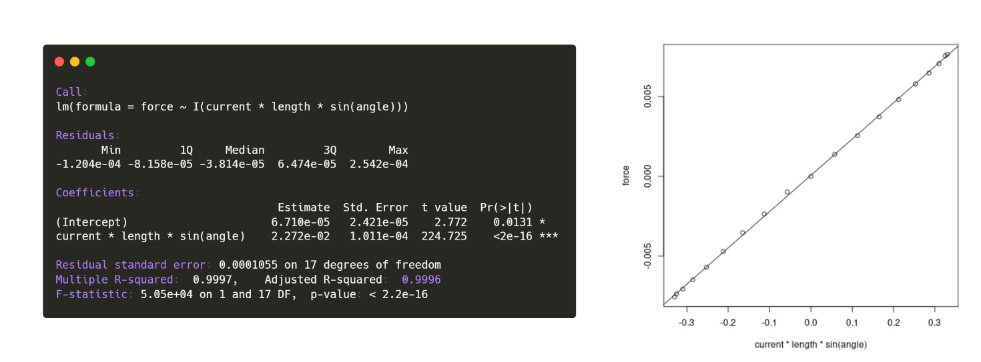

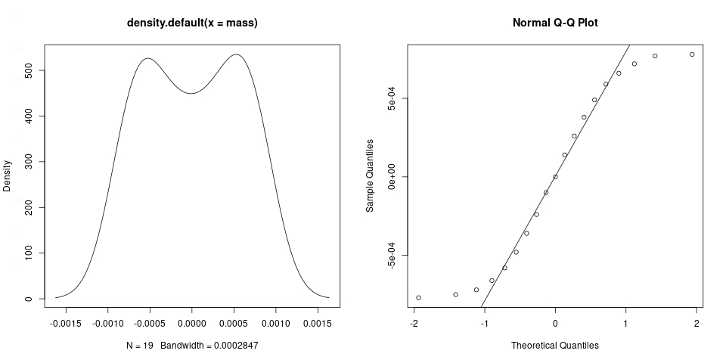

Non-rejectionable Gaussianity for samples only. From the Shapiro-Wilk test we get 0.05728 > 0.05 for mass, 0.02078 < 0.05 for residuals. There is no certainty about the homo- or heteroschedasticity of the residuals, all we can say from the plot "res vs fitted" is that the residuals do not have a linear trend, they have finite variance but the pattern they describe does not seem to have a random trend. Regression globally significant (low p-value of F-test). Intercept less significant than the other predictor (0.0201 >> 10-16) this allows not to consider it in the model. R2 e R2adj are satisfactory.

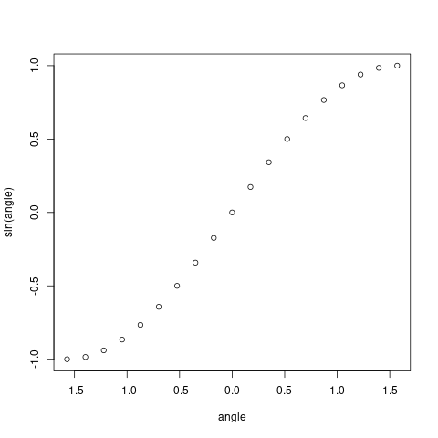

As per practice we leave the code used for data analysis. More info [here](https://github.com/Fylls/electromagnetism-experiment/tree/main/statistics).

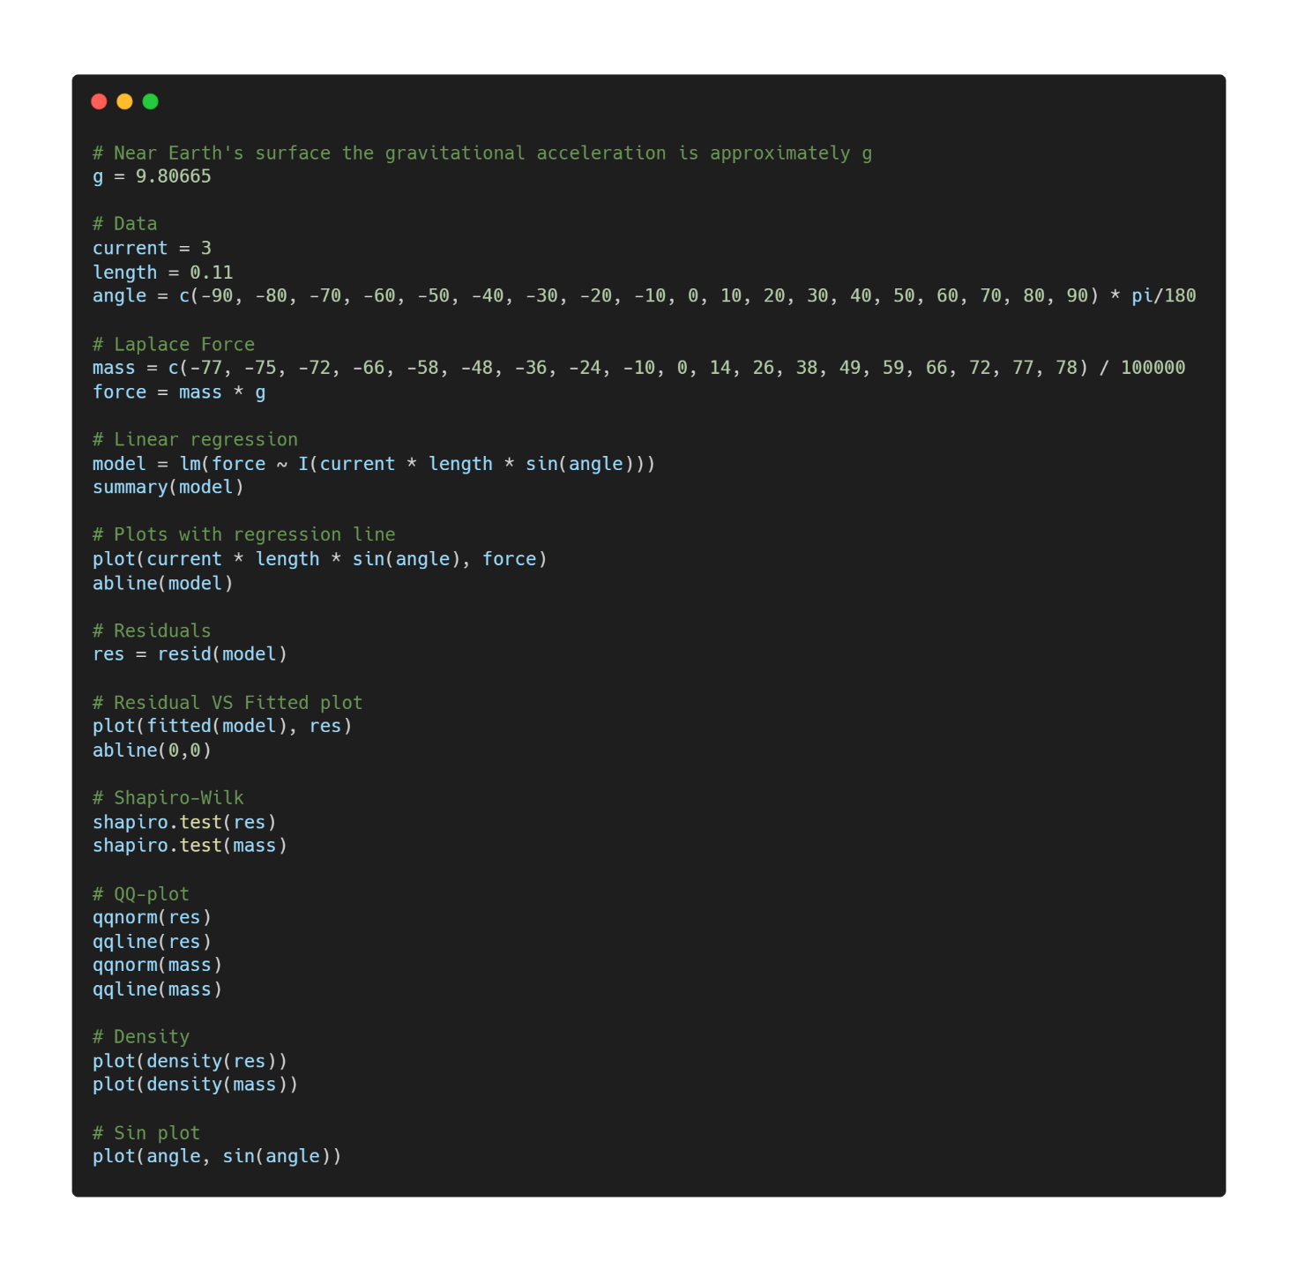

**Conclusions**

In general, this experience turned out to be very instructive, not only from a notionistic point of view, but especially because it allowed us to appreciate the differences between theoretical models and experimental data, pushing us to find reasons for these inconsistencies. Physics is fascinating even when it doesn't work!

**Acknowledgements**

**Software:**

**R:** programming language

**Python:** programming language

**Numpy:** python library

**Pandas:** python library

**Seaborn:** python library

**Scipy:** python library

**Jupyter Notebook:** IDE for python

**Adobe** **Photoshop:** photo editing software

**Microsoft Excel:** data collection

**Web Services:**

**Carbon.now:** easy sharing of source code via images

**Rdrr.io:** online IDE for R (R studio alternative)

**Imgonline.com.ua:** online tool to quickly edit images

**Github.com:** opensource repositories. All the material of this research can be found here

**Desmos.com:** online graphic calculator. Useful for sharing interactive graphs

**Images:**

**Pasco Scientific**: images of the esperimental apparatus

**Literature:**

**Ioannidis** (2005) "Why Most Published Research Findings Are False"